# 实验一：实例分析与数据库的设计

# 实例要求

帮助自己管理支出金额，导出月份应该报销的金额 & 个人透支金额

本项目采用golang开发

# 建立一个项目实例，将需求用文字描述出来，格式如下

功能1：（公司报销表）保存用户每天支出金额

功能1.1 自动插入当前系统时间

功能1.1.1 每一次的支出最多50元

功能2：（私人透支表）保存用户每天透支的金额

功能2.1 自动插入当前系统时间

功能2.1.1

功能3：查询公司应报销金额

功能3.1：查询用户个人透支金额

功能3.1.1：查询某段时间区间用户花费金额

# ER图

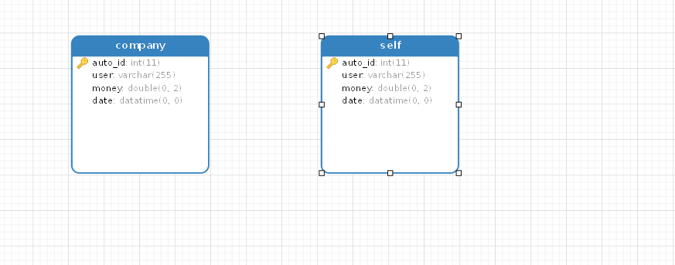

# 数据字典

Auto_ID：自增的id，用于充当主键

User： 用户名

Money： 花费金额

Date： 花费时间

# 数据库设计

### 数据库表

company表

|  |  |  |  |  |
| --- | --- | --- | --- | --- |
| 字段名 | 类型 | 默认值 | 是否主键 | 备注 |
| auto_id | int | Auto_increment | Y |  |
| user | varchar |  |  |  |
| money | double |  |  |  |
| date | datetime | CURRENT_TIMESTAMP |  |  |
|  |  |  |  |  |
|  |  |  |  |  |

selft表

|  |  |  |  |  |
| --- | --- | --- | --- | --- |
| 字段名 | 类型 | 默认值 | 是否主键 | 备注 |
| auto_id | int | Auto_increment | Y |  |
| user | varchar |  |  |  |
| money | double |  |  |  |
| date | datetime | CURRENT_TIMESTAMP |  |  |
|  |  |  |  |  |

### 使用navicat建立表后的图



### Sql语句

**[Download as text](https://paste.ubuntu.com/p/MDG6hnGgTX/plain/)**

|  |  |
| --- | --- |
| 1  2  3  4  5  6  7  8  910  11  12  13  14  15  16  17  18  1920  21  22  23  24  25  26  27  28  2930  31  32  33  34  35  36  37 | **DROP** **TABLE** **IF** **EXISTS** `company`;  **CREATE** **TABLE** `company` (  `auto_id` **int**(11) **NOT** NULL AUTO_INCREMENT COMMENT 'primary key',  `user` **varchar**(255) **COLLATE** utf8mb4_unicode_ci **DEFAULT** NULL,  `money` **double**(255,2) **DEFAULT** NULL,  `time` **datetime** **NOT** NULL **DEFAULT** **CURRENT_TIMESTAMP**,  **PRIMARY** **KEY** (`auto_id`),  **KEY** `user` (`user`)) ENGINE=InnoDB AUTO_INCREMENT=46 **DEFAULT** CHARSET=utf8mb4 **COLLATE**=utf8mb4_unicode_ci;  **DROP** **TABLE** **IF** **EXISTS** `self`;  **CREATE** **TABLE** `self` (  `auto_id` **int**(11) **NOT** NULL AUTO_INCREMENT COMMENT 'autoIncreasment\r\n',  `user` **varchar**(255) **COLLATE** utf8mb4_unicode_ci **DEFAULT** NULL,  `money` **double**(255,2) **DEFAULT** NULL,  `time` **datetime** **NOT** NULL **DEFAULT** **CURRENT_TIMESTAMP**,  **PRIMARY** **KEY** (`auto_id`)) ENGINE=InnoDB AUTO_INCREMENT=23 **DEFAULT** CHARSET=utf8mb4 **COLLATE**=utf8mb4_unicode_ci;  **LOCK** TABLES `company` **WRITE**;  **INSERT** **INTO** `company` **VALUES** (19,'vimi',50.00,'2018-03-25 05:54:56'),(20,'vimi',32.00,'2018-03-25 05:56:18'),(21,'vimi',45.50,'2018-03-25 14:37:38'),(22,'aki',50.00,'2018-03-25 14:42:53'),(23,'aki',50.00,'2018-03-25 14:45:10'),(24,'vimi',50.00,'2018-03-25 14:50:39'),(25,'vimi',50.00,'2018-03-25 14:51:31'),(26,'vimi',50.00,'2018-03-25 14:53:26'),(27,'vimi',50.00,'2018-03-25 15:01:08'),(28,'test',50.00,'2018-03-25 15:02:21'),(29,'jjj',50.00,'2018-03-25 15:37:52'),(30,'sadf',50.00,'2018-03-25 16:30:50'),(31,'23',32.00,'2018-03-25 16:31:15'),(32,'22',50.00,'2018-03-25 16:31:53'),(33,'vimi',50.00,'2018-03-26 05:22:47'),(34,'jack',50.00,'2018-03-26 05:34:00'),(35,'vimi',50.00,'2018-03-26 05:41:30'),(36,'vimi',50.00,'2018-03-26 05:45:22'),(37,'asdf',0.50,'2018-03-26 05:45:29'),(38,'vimi',34.00,'2018-03-26 05:50:45'),(39,'asdf',50.00,'2018-03-26 05:52:13'),(40,'testq',50.00,'2018-03-26 05:53:04'),(41,'vimi',23.00,'2018-03-26 06:06:00'),(42,'vimi',2.00,'2018-03-26 06:06:35'),(43,'q',2.00,'2018-03-26 06:11:02'),(44,'vpn',50.00,'2018-03-26 07:28:05'),(45,'vpn',50.00,'2018-03-26 07:28:13');  **UNLOCK** TABLES;  **LOCK** TABLES `self` **WRITE**;  **INSERT** **INTO** `self` **VALUES** (4,'vimi',19.00,'2018-03-25 05:54:55'),(5,'aki',35.00,'2018-03-25 14:42:53'),(6,'aki',35.00,'2018-03-25 14:45:10'),(7,'vimi',394.00,'2018-03-25 14:50:39'),(8,'vimi',394.00,'2018-03-25 14:51:30'),(9,'vimi',394.00,'2018-03-25 14:53:26'),(10,'vimi',172.00,'2018-03-25 15:01:08'),(11,'test',73.00,'2018-03-25 15:02:21'),(12,'jjj',73.00,'2018-03-25 15:37:51'),(13,'sadf',172.00,'2018-03-25 16:30:50'),(14,'22',283.00,'2018-03-25 16:31:52'),(15,'vimi',184.00,'2018-03-26 05:22:46'),(16,'jack',514.00,'2018-03-26 05:34:00'),(17,'vimi',2273.00,'2018-03-26 05:41:30'),(18,'vimi',6.99,'2018-03-26 05:45:21'),(19,'asdf',162.00,'2018-03-26 05:52:13'),(20,'testq',73.00,'2018-03-26 05:53:03'),(21,'vpn',200.00,'2018-03-26 07:28:05'),(22,'vpn',300.00,'2018-03-26 07:28:13');  **UNLOCK** TABLES; |